Honeywell Enviracom®

Enviracom Bus Monitor

This document is for informational purposes only. Honeywell makes no warrenties, express or implied, in this document.
The furnishing of this document does not grant any license to any patents, trademarks, copyrights, or other intellectual property rights except as expressly provided in any written license agreement from Honeywell.
Honeywell does not make any warranty that any item developed based on these specifications, either in whole or in part, will not infringe any copyright, patent, trade secret or other intellectual property right of any person or entity. Honeywell shall not be liable for any damages arising out of or in connection with the use of these specifications. Some states do not allow the exclusion or limitation of liability or consequential or incidental damages, therefore the above limitation may not apply to you.

Any product that uses the Enviracom® name or symbol or that claims to be Enviracom® compatible must be tested for conformance to all of the Enviracom® specifications.
DOCUMENT REVISION CONTROL LOG
Revision | Date | Description
0.1 | 5 Feb, 2005 | Initial revision
0.2 | 6 Jun, 2005 | Updated DUT definition in database  Updated Identifying Devices to Test
0.3 | 23 Jul, 2005 | Added Serial Adapter Protocol
0.4 | 5 Feb, 2006 | Added paste procedure for data field in toolbar
0.5 | 10 Jul, 2006 | Corrected DUT definition description in database

TABLE OF CONTENTS
1. Introduction 7
2. Creating Device Files 8
3. Installation 13
3.1 Using the W8735A Enviracom Serial Adapter 13
4. Starting the Enviracom Bus Monitor 14
5. Identify System Devices 16
6. Main Window 18
6.1 Message Log Window 18
6.1.1 Message Decode View 19
6.1.2 Raw Bit View 20
6.2 Error Log Window 20
6.3 Field Values Window 20
6.3.1 Display Current Value of Configured Message Fields 20
6.3.2 Display All Fields In a Logged Message 21
6.4 Window Divider, Horizontal Adjustment 21
6.5 Window Divider, Vertical Adjustment 21
6.6 Toolbar Buttons 22
6.6.1 Restore Saved Log 22
6.6.2 Save Log To A File 22
6.6.3 Copy Log To Clipboard 22
6.6.4 Print Log 22
6.6.5 Message Class Selector 22
6.6.6 Instance Selector 22
6.6.7 Service Selector 22
6.6.8 Search Down 22
6.6.9 Search Up 22
6.6.10 Priority Selector 22
6.6.11 Data Field Values 23
6.6.12 Send Message 23
6.6.13 Plot Data 23
6.6.14 Comm Port Selector 23
6.6.15 Automated Tests 23
6.6.16 Version 23
6.7 Current Bus Utilization 23
6.8 Script Currently Executing 23
7. Scripts 25
7.1 Comment 25
7.2 Send an Enviracom Message 25
7.3 Wait for Bus Idle 25
7.4 Wait for Specific Amount of Time 25
7.5 Wait for System Power Off 26
7.6 Wait for System Power On 26
7.7 Display Text Message 26
8. Conformance Testing 27
8.1 Automated Tests 27
8.1.1 Physical Layer Test 27
8.1.2 Data Link Layer Test 28
8.1.3 Basic Functional Unit Test 28
8.1.4 Additional Functional Unit Test 28
8.2 Script Tests 28
8.3 Functional Tests 28
9. Serial Adapter Protocol 29
9.1 From EnviraCOM Serial Adapter to PC 29
9.2 From PC to EnviraCOM Serial Adapter 29

Introduction
The Enviracom Bus Monitor is a PC based tool to aid in the development and testing of Enviracom devices.

System Requirements:
- Windows 98, NT, ME, 2000, XP
- Serial port, 19.2K baud
- >= 1GHz clock speed
- 1 Mbyte free hardrive space
- 250 Mbytes RAM
- XVGA display or greater
- Microsoft Excel 97 or later
- Microsoft Access 97 or later

A modified Enviracom Serial Adapter interfaces the Enviracom three-wire bus to the serial port on the PC as shown in Figure 1.
Modified Enviracom Serial Adapter
Enviracom Devices
24VAC Transformer
Personal Computer
Enviracom
Serial

24V transformer is required for 120V. Wires go into pin 2 and 3. Updated wiring. Information below

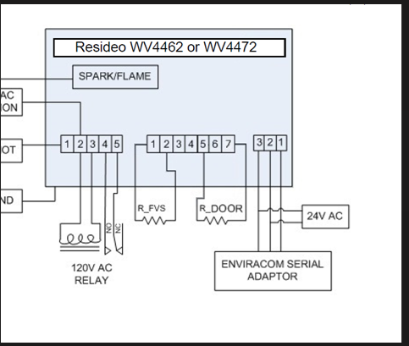

Figure 1: Enviracom Bus Monitor System Diagram
The Enviracom Bus Monitor is compatible with either standard or fast Enviracom, requiring only a compatible Enviracom Serial Adapter to configure itself.

Creating Device Files
The Enviracom Bus Monitor needs to know what messages are present in every device on the system in order to test whether a message it sees is compliant with the specifications. It obtains this information from device files created with the Enviracom database. The database is contained in file SystemDesign.mdb, which is distributed with the specification documents each time a new spec revision is released. It requires Microsoft Access 2003 or later to be installed to make use of it. To create a device file, first open the file, SystemDesign.mdb, either from within Access or by double clicking on the file from Windows Explorer. The Enviracom database will look like Figure 2.
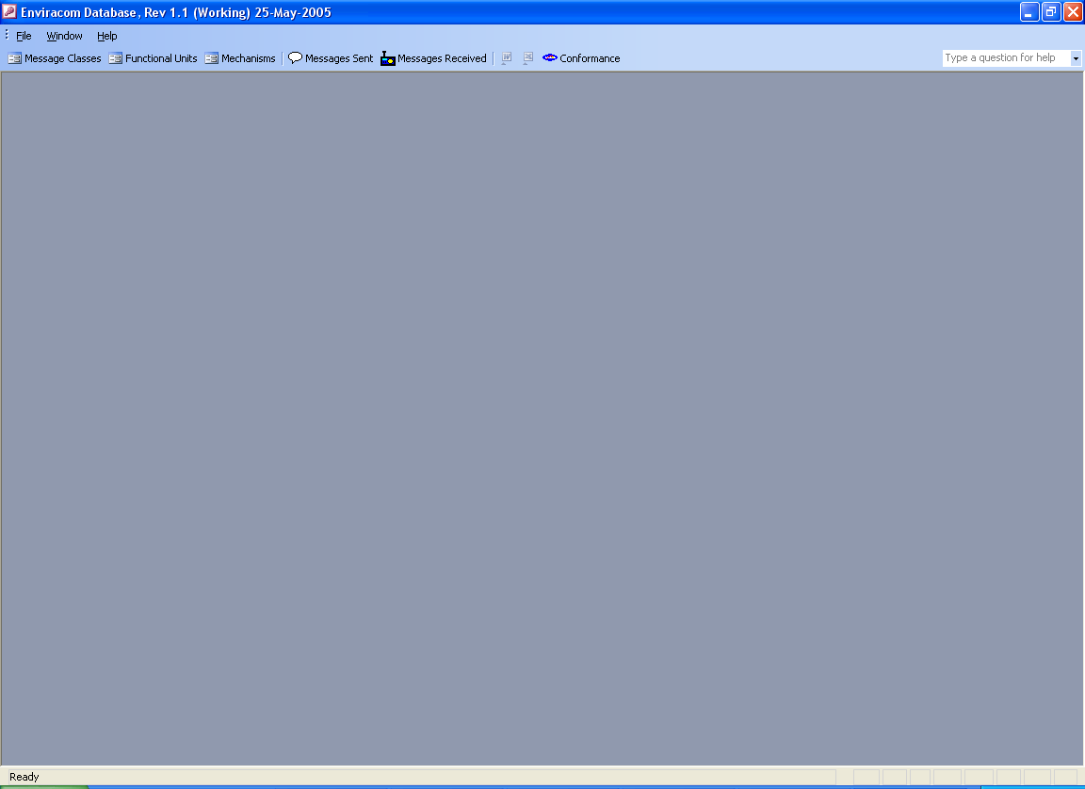Figure 2: Enviracom Database

Click on the Conformance button on the toolbar near the top of the window. A dialog box will appear that is shown in Figure 3.
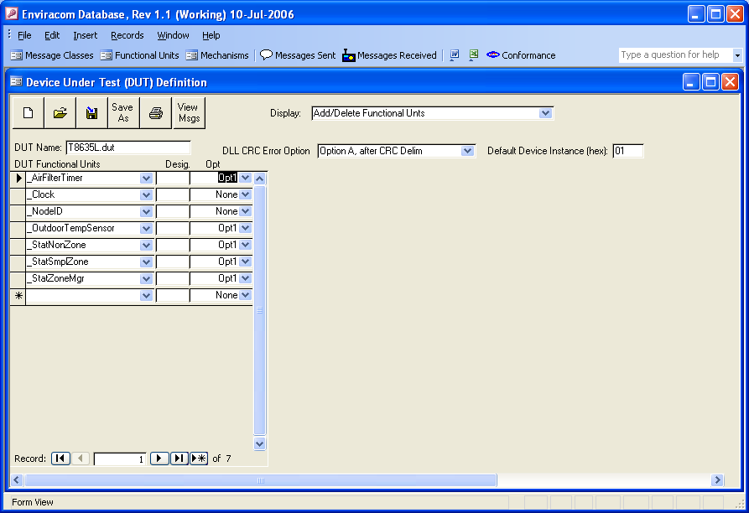Figure 3: Device Under Test (DUT) Definition
Near the center top is a combo box labled “DLL CRC Error Option”. Refer to the Enviracom Data Link Layer specification for a description of this option. Select which of the two options is used in the device. (Most devices will use option A).

Near the right top is a text box labeled ‘Default Device Instance (hex)’. Some devices will send messages whose instance value can change at run time. For example, the instance field of many messages in a zoned thermostat will be the thermostat’s zone number. If the device has messages that fit into this category, enter the device’s default ‘Device Instance’ field value here as two hexidecimal characters (no H). If the device has no messages that fit into this category, enter 00.

To the left of the dialog box is a list box where you must enter all of the fuctional units that are in the device. Initially only the _NodeID functional unit is listed because all devices must have this functional unit. Enter more functional units one at a time by selecting the down arrow on the blank entry at the bottom of the list. A drop down list will appear showing all of the possible functional units. Select one from the list and it will be shown at the bottom of the list followed by another blank entry. To the right of the functional unit name is a column called ‘Desig.’. When a device contains multiples of the same functional unit, you must enter a unique set of characters to distinguish the duplicate functional units. If a functional unit is not duplicated, this column can be left blank. To the right of the ‘Desig.’ column is an ‘Opt’ column containing a combo box. If the functional unit can be disabled at run time, change its value to “Opt1”, otherwise leave it at “None”. Continue this process until all of the device’s functional units have been identified. To delete a functional unit, select its right arrow to the left of the functional unit and press the delete key. Once a functional unit has been identified, do not change its name. If the wrong functional unit is selected, delete the functional unit and add the correct one.

Now that the functional units are known, you must identify which of the optional messages for each of the functional units are implemented in the device. In the combo box at the top of the dialog box labled “Display”, change the selection from “Add/Delete Functional Units” to “Optional Messages Sent by the Functional Unit”. The window changes as shown in Figure 4.

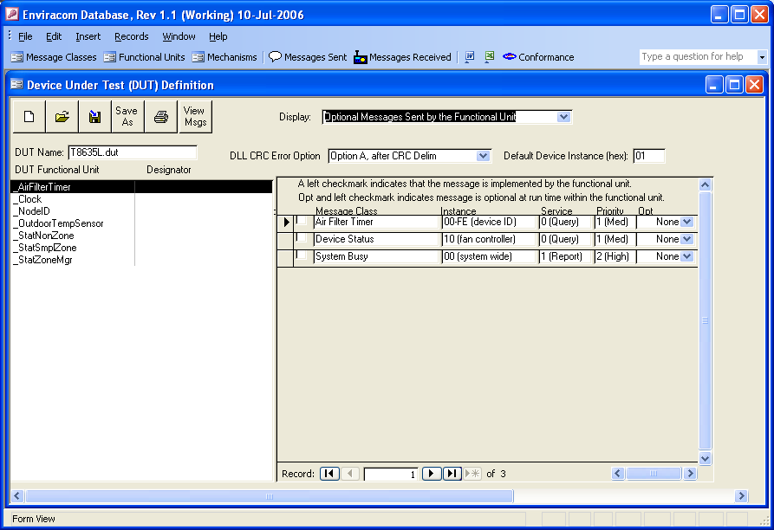Figure 4: Optional Messages Sent by the Functional Unit
Select each functional unit one at a time from the list on the left side and a list of optional messages the functional unit may send will appear on the right. Click on the small box to the left of any message to put a checkmark indicating the device sends the message. Click again to remove the checkmark.

Some messages may be optionally disabled at run time even though their funtional unit is enabled. For these types of messages, change the combo box in the Opt column to “Opt1” Otherwise leave it at “None”. A message that is disabled because its functional unit is disabled at run time does not need a check mark.

Once the optionally sent messages have been identified, change the selection in the ‘Display’ combo box to “Optional Messages Received by the Functional Unit”. Repeat the process used above for the received messages for each functional unit.

Once all optional sent and received messages have been identified, change the selection in the ‘Display’ combo box to “Identify Specific Sent Msg Instances”. Select each functional unit one at a time and a list of messages for which the instance field needs to be identified will appear on the right. As shown in Figure 5.
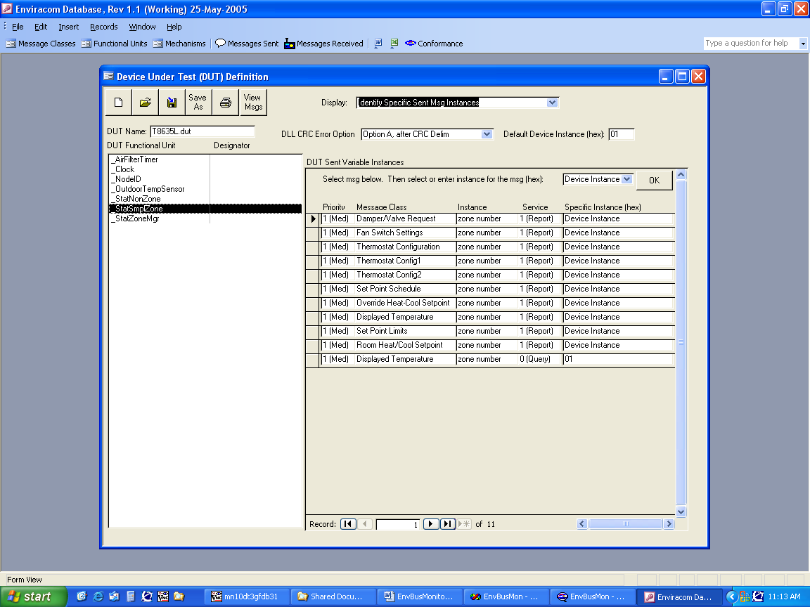Figure 5: Identify Specific Sent Msg Instances

Select each functional unit on the left, one at time. For each functional unit, select each message on the right, one at a time by clicking on the ‘Specific Instance’ column. If the message is always sent with the same instance value, type the value in hex (two characters, no ‘H’) in the combo box next to the OK button. If the message is sent with the assigned device instance value, select “Device Instance’ from the combo box. If the message is sent with all possible instances, select ‘All Instances’ from the combo box. If the message is sent with a range of values, select ‘From / To’ from the combo box, and then enter the minimum instance and maximum instance values (two character hex) in the text boxes that appear. When the instance value(s) for the message have been specified, click the ‘OK’ button and go on to the next message. Continue this until all messages in all functonal units have been specified.

Then change the selection in the ‘Display’ combo box to “Identify Specific Receive Msg Instances”, and repeat the above steps for the receive messages.

At this point, all the information needed by the Enviracom Bus Monitor for the device has been identified. Save the information to a file by clicking the ‘Save As’ button. A dialog box will appear allowing you to select the directory and file name. It is recommended you select the directory where the Enviracom Bus Monitor program is located, although it may be any directory. The file name must be unique to any other device file name that would be used simultaneously in the same system. A .dut extension is automatically appended to the file name if it does not already have one. Once the .dut file has been saved, you can click the Save button at any time to save the file again.

To see what messages the device sends and receives, click the ‘View Msgs’ button. A report will appear allowing you to see all the messages. While the report is being viewed, you can click on the ‘W’ button in the main toolbar to export the report to MS Word, or the ‘X’ button in the main toolbar to export the report to MS Excel.

Close the ‘Device Under Test Definition’ dialog box by selecting the close button in the upper right corner of the dialog (the one with the X)

To exit the Enviracom database, select the close button in the upper right corner of the window (the one with the X).

Installation
The Enviracom Bus Monitor consists of two files:
- EnvBusMon.exe
- EnvBusMonPlot.xls
In addition, the Enviracom Bus Monitor makes use of a data base info file that is distributed with the Enviracom specifications:
- EBMMsgDecodeFile.txt

In order for the Enviracom Bus Monitor to work correctly, all three files must be installed in the same directory. It is recommended that they be installed in the same directory as the Enviracom specifications and Enviracom database so that the monitor will automatically recognize updates to the specifications.

Using the W8735A Enviracom Serial Adapter
The W8735A Enviracom Serial Adapter can be used to interface the Enviracom Bus Monitor to a standard speed Enviracom system. However, the W8735A software must be updated before it can be used with the Enviracom Bus Monitor. The software update process requires two files:
- flashit.exe
- W8735A.s19
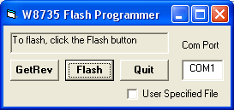
Both of these files are contained in the zip file containing the Envracom Bus Monitor software. These two files must be installed in the same directory. To update the files, remove 24VAC power from the W8735A and connect the W8735A to the PC with a serial cable. Run the file flashit.exe. A dialog box shown in Figure 6 will appear.

Figure 6: W8735A Flash Programmer

Type in the correct comm port in the text box at the right, and make sure the User Specified File box is unchecked. Click the ‘Flash’ button, and within 10 seconds, apply 24VAC power to the W8735A (terminals 2 and 3). The program will begin reflashing the W8735A. When done, click the ‘Quit’ button.
NOTE: Once the W8735A is reflashed, it can only be used with the Enviracom Bus Monitor.

Starting the Enviracom Bus Monitor
Connect the Enviracom Bus Monitor serial adapter to the Enviracom devices to monitor. Connect the Enviracom devices to a system 24VAC transformer. Connect the Enviracom Bus Monitor serial adapter to a free serial port on the computer. Apply power to the 24VAC transformer, or optionally apply power after the program has started. Start the Enviracom Bus Monitor by running the program file, EnvBusMon.exe.

Identify System Devices
The Enviracom Bus Monitor must know what devices are in the system and what messages they send and receive to accurately detect messaging errors. When the Enviracom Bus Monitor program starts, a window appears allowing you to enter the Enviracom devices that are in the system, as shown in Figure 7.
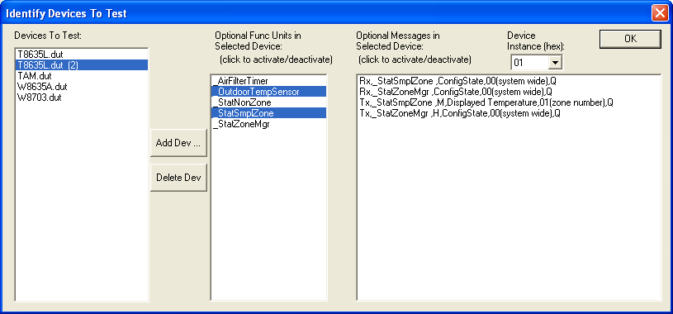Figure 7: Identify Devices To Test
Devices are identified by the name of the .dut file created by the Enviracom database according to Section 2. Refer to that section of this document for instructions to create a .dut file. The list box on the left contains the list of devices that you have selected to be present. If more than one of the same device is present, it will be identified after the name by a unique number in parenthesis. The list of devices is automatically restored from the last time the program ran. To delete a device from the list, select the device with the mouse, then click on the ‘Delete’ button. To add devices to the list, click on the ‘Add …’ button, which brings up a dialog box from which you can browse to find the .dut files to add. Multiple .dut files can be simultaneously selected in this dialog box. Clicking on the ‘OK’ button will close the dialog box and add the selected .dut files to the list.

The center list box contains all of the functional units in the highlighted device that were identified as optional in the .dut file. The bus monitor will assume only the highlighted functional units are active. The non-highlighted functional units will be ignored. To toggle the highlight, simply click on the functional unit.

The right list box contains all of the messages in the highlighted device that were identified as optional in the .dut file. The bus monitor will assume only the highlighted messages are active. The non-highlighted messages will be ignored. To toggle the highlight, simply click on the message.

The Device Instance combo box in the upper right identifies the ‘Device Instance’ of the highlighted device. This value will be uses in the Instance field of messages that were identified in the .dut file to have an instance field of “Device Instance. If no messages were identified in the .dut file to have an instance field of ‘Device Instance’, then this combo box will be ignored.

When the device list is correct, and the optional functional units, optional messages, and device instance have been verified for each device, click on the ‘OK’ button to close the Identify Devices to Test dialog box.

NOTE: Sometimes it may be desired to monitor and display all bus traffic but not check for messaging errors. Deleting all devices in the list will do this.

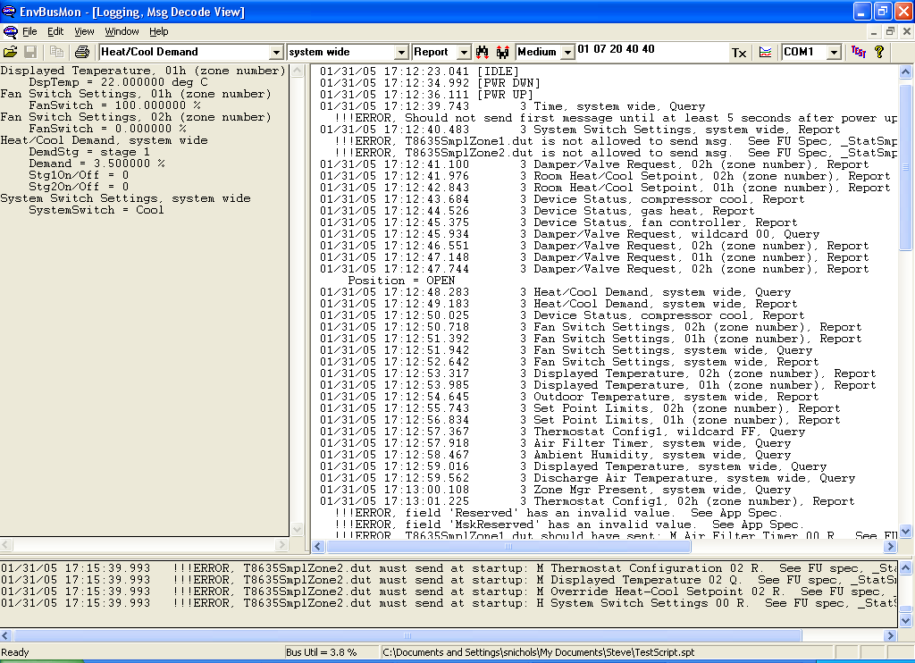
Main Window
Restore saved log file
Field values window
Error log window
Current bus utilization
Script currently executing
Status
Message log window
Save log to file
Copy log to clipboard
Print log
Message class selector
Instance selector
Service selector
Window divider horizontal adjustment
Window divider vertical adjustment
Search down
Search up
Priority selector
Data field values
Send message
Plot data
Comm port selector
Automated test
Version
The Enviracom Bus Monitor main window is shown in Figure 8.
Figure 8: Main Window
The Main Window contains the following items:

Message Log Window
The message log window contains a log of each enviracom message in sequential order. This window is actually two overlapped windows:
- Message Decode View – this window is shown in Figure 8 and shows a decoded display of each message.
- Raw Bit View – this window is shown in and shows each bit that occurs on the bus, organized by data link layer field.
You may select which of the two windows gets displayed from the ‘Window’ menu. In addition, the two log windows can be displayed simultaneously from the ‘Window’ menu by selecting ‘Tile’.

Message Decode View
The following is an example message entry in the message decode view:
Figure 9: Message Decode View Entry
01/31/05 20:35:46.926 3 Heat/Cool Demand, system wide, Report M 3110 00 R 01 07 20 40 40
Timestamp – date and time
Number of bits since last message
Message class
Instance
Service
Priority
H = High
M = Medium
L = Low
Message Class ID (hex)
Instance (hex)
Service
C = Change
R = Report
Q = Query
Data field (hex)

When data changes, the changed field values are logged just below the message entry. Any messaging errors are also logged.

The following are also logged:
[IDLE] – the bus is idle
[PWR DWN] – 24VAC system power has been removed
[PWR UP] – 24VAC system power has been restored

This view is limited to approximately 1,000,000 characters. When the view gets to this size, all data is automatically saved in a log file having a file name of ‘EBMLogMM_DD_YY hh_mm_ss.mon’ where
MM = month
DD = day of month
YY = year
hh = hours
mm = minutes
ss = seconds
and represents the first timestamp in the log. The views are automatically cleared and begin filling up again as messages are received.

Raw Bit View
The raw bit view can be enabled from the message decode view by double clicking on a logged message entry. Similarly, the message decode view can be enabled from the raw bit view by double clicking on an entry. The following is an example entry in the raw bit view:

Figure 10: Raw Bit View Entry
02/01/05 20:04:48.400 3 D rD DDrrrDDrrrrr+rr rrr+rrrDr rD rrrrr+D rrrrr+rrr rr+rrrDDrDDrDrrrr Dr rrrrrrr
Timestamp – date and time
Number of bits since last message
Message bits

A dominant bit is shown with the ‘D’ character, a recessive bit is shown with the ‘r’ character, a dominant stuff bit is shown with the ‘+’ character, and a recessive stuff bit is shown with the ‘-‘ character.
Any messaging packet errors are also logged in this view.

Error Log Window
This window contains a list of all the errors in the message decode and raw bit views. An entry in this window means that one or more devices in the system are not conforming to the Enviracom specifications. Double clicking on any error in this window will enable the correct view and scroll to the logged error. After 100 errors are logged, this window will not add any more, although the message log window will continue to log errors.

Field Values Window
This window displays message field values in two ways. First, it displays the current value of configured fields. Second it decodes and displays the value of all fields in any message logged in the message log window.

Display Current Value of Configured Message Fields
To configure the window to display the current value of a field, double click anywhere in the field values window and the following dialog box will appear:
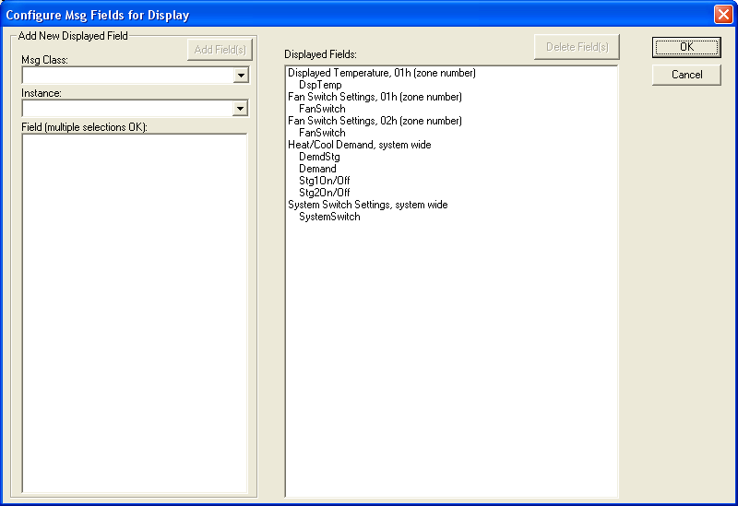
Figure 11: Configure Msg Fields for Display
The list box to the right displays the list of fields that are displayed. To delete a field from the list, select it with the mouse, then click the ‘Delete Field(s)’ button. Multiple fields may be simultaneously selected. To add a field to the list, select a message class with the Msg Class dropdown menu, select the instance with the Instance dropdown menu and select one or more fields in the ‘Field (multiple selections OK)’ list box. When satisified with the list of fields, click the ‘OK’ button.
Whenever a message containing any of the configured fields is sent or received, the field’s value will be updated.

Display All Fields In a Logged Message
Whenever the left mouse button is clicked and held while the cursor is over a logged message in the Message Log Window (either the message decode view or raw bit view), the display in the Field Values Window is replaced with all of the field values in the selected message. These values will stay as long as the left mouse button is held. As soon as the left mouse button is released, the display reverts back to the configured message fields.

Window Divider, Horizontal Adjustment
By selecting and dragging the vertical bar between the Field Values Window and the Message Log Window, the sizes of the two windows can be adjusted.

Window Divider, Vertical Adjustment
By selecting and dragging the horizontal bar between the Error Log Window and the Message Log Window/Field Values Window, the sizes of the windows can be adjusted.

Toolbar Buttons

Restore Saved Log
This button brings up an ‘Open File’ dialog box from which you may select a previously saved log file. A log file must have a .mon extension.

Save Log To A File
This button brings up a ‘Save File’ dialog box from which you may select a path and enter a file name to save the current log. Saving does not delete the current log.

Copy Log To Clipboard
This button will copy any highlighted text in the message log window to the clipboard. The equivalent can be done with the Ctrl-C keys. Note that you cannot paste into the message log window.

Print Log
This button will print any highlighted text in the message log window. Note that only text that has been highlighted will be printed. Pressing the Ctrl-A keys when the message log has focus will highlight the entire log.

Message Class Selector
This control selects the message class used by the Search Down, Search Up, and Send Message buttons on the toolbar. A message class is selected using the dropdown arrow to the right of the control. Alternatively, right clicking on a logged message in the Message Log Window will select the message class in that message.

Instance Selector
This control selects the instance field used by the Search Down, Search Up, and Send Message buttons on the toolbar. An instance is selected using the dropdown arrow to the right of the control. Alternatively, right clicking on a logged message in the Message Log Window will select the instance in that message.

Service Selector
This control selects the service field used by the Search Down, Search Up, and Send Message buttons on the toolbar. A service is selected using the dropdown arrow to the right of the control. Alternatively, right clicking on a logged message in the Message Log Window will select the service in that message.

Search Down
This button searches the message log from the cursor location until it finds the next message with the same message class, instance, and service as configured in the Message Class Selector, Instance Selector, and Service Selector.

Search Up
This button searches the message log from the cursor location until it finds the previous message with the same message class, instance, and service as configured in the Message Class Selector, Instance Selector, and Service Selector.

Priority Selector
This control selects the priority field used by the Send Message button on the toolbar. A priority is selected using the dropdown arrow to the right of the control. Alternatively, right clicking on a logged message in the Message Log Window will select the priority in that message.

Data Field Values
This control selects the data field values used by the Send Message button on the toolbar. Data field values are enterred as two characters for each byte (hexidecimal), seperated by a space character. Alternatively, right clicking on a logged message in the Message Log Window will select the data field values in that message. It is possible to paste data into this control by right clicking on the control, then selecting ‘Paste’ on the popup menu. (Note that Ctrl+V will not paste into this control.

Send Message
This button causes the monitor program to send an Enviracom message on the bus containing the contents of the Message Class Selector, Instance Selector, Service Selector, Priority Selector, and Data Field Values controls.

Plot Data
This button creates a time plot of all of the configured fields in the Field Values Window. Data to create the plot is obtained from the entire contents of the message log window, meaning that this feature works with saved logs as well as current logs. Microsoft Excel must be installed in order to make use of this feature.

Comm Port Selector
This control selects the comm port that is connected to the Enviracom Bus Monitor Serial Adapter.

Automated Tests
This button initiates automated compliance testing of a device. See section Error: Reference source not found for more details.

Version
This button brings up a dialog box that displays the version of the Enviracom Bus Monitor, as well as the version of the Enviracom database from which the messaging test rules were obtained.

Current Bus Utilization
This pane located on the bottom status bar displays the current bus utilization as a percentage. This number is updated approximately once a minute and represents the bus utilization over the previous minute.

Script Currently Executing
This pane located on the bottom status bar displays the currently running script. See Section 7 for more details on scripts. If no script is running, this pane is blank.

Scripts
The Enviracom Bus Monitor has the capability to execute a series of steps where a step can be one of the following:
- Send an Enviracom message
- Wait for the Enviracom bus to go idle
- Wait a specific amount of time
- Put up a message asking the user to turn off the system power and then wait until power is removed
- Put up a message asking the user to turn on the system power and then wait until power is restored
- Put up a message and wait until the user presses the ‘OK’ button

The series of steps is called a script and is encoded in a text file. The file can be created from any text editor where each step is one line of text. Script file names must always end with a .spt extension.

To execute a script file, select ‘File’, ‘Execute Script File …’ from the menu at the top of the main window. A dialog box will appear allowing you to browse for a previously created script file. When the script file is selected, click on the ‘Open’ button. The message decode view will log that the script started, and the script file will appear in the ‘Script Currently Executing’ pane at the bottom of the main window. When the script ends, the message decode view will log that the script ended, and the ‘Script Currently Executing’ pane will go blank.

The following explains how to encode the various script line types:

Comment
Any line in a script file that begins with the ‘;’ character is ignored when executing the script.

Send an Enviracom Message
An Enviracom message is encoded as a consecutive string of ‘+’ and ‘-‘ characters, where the ‘+’ character represents a dominant bit and the ‘-‘ character represents a recessive bit. The string represents the exact sequence of bits that will be sent on Enviracom, which includes Stuff bits, SOF field, Ack field, CRC field, EOF and Intermission fields. The string must not exceed 800 Enviracom bits and can represent back to back messages or even partial messages. The bit string will attempt to be sent at the next opportunity (when the bus is idle, or after an intermission field). If the bit string loses arbitration while being sent, it will abort and attempt to resend the complete bit string again at the next opportunity. The step does not end until the complete bit string is sent.

To aid in creating a ‘Enviracom Message’ step in a script file, simply send an Enviracom message using the ‘Send Message’ button described in Section 6.6.12. The bit string necessary to encode the message in a script file is copied to the clipboard. Just paste it into the script file.

Wait for Bus Idle
A line in a script file that begins with the ‘I’ character will cause script execution to wait until the Enviracom bus goes idle before advancing to the next line.

Wait for Specific Amount of Time
A line in the script file that begins with the ‘W’ character and is immediately followed by an integer number (no space) will cause script execution to wait for the given number of seconds before advancing to the next line. While waiting, a small window will appear counting down the time remaining.

Wait for System Power Off
A line in the script file that begins with ‘P-“ will cause a small window to be displayed asking the user to turn off system power. When system power goes away, the small window automatically closes and script execution advances to the next line. If system power is already turned off when this line executes, script execution advances to the next line without putting up the window.

Wait for System Power On
A line in the script file that begins with ‘P+“ will cause a small window to be displayed asking the user to turn on system power. When system power is turned on, the small window automatically closes and script execution advances to the next line. If system power is already on when this line executes, script execution advances to the next line without putting up the window.

Display Text Message
A line in the script file that begins with the ‘T’ character will cause a small window to be displayed with a text string containing all characters after the ‘T’ character. When the user clicks the ‘Ok’ button, the small window disappears and execution advances to the next line.

Conformance Testing
Every Enviracom product must be tested for conformance to the Enviracom specifications. It is the responsibility of product developers to test their products. The Enviracom Bus Monitor was created to make this task easier to perform. Since it automatically checks each message it sees against the rules for that message in the Enviracom specifications, confomance testing becomes a matter of monitoring Enviracom traffic while a product is put through three conformance test groupings. The three groupings are automated tests, script tests, and functional tests.

NOTE: Enviracom conformance does not require that the data field in any sent message be accurate. Data accuracy is a matter of product quality, not conformance. Even though data accuracy is not a requirement, we expect most developers of Enviracom products will care very much about the accuracy of their data and will test this thoroughly. The Enviracom Bus Monitor can decode the data field and thus make testing data accuracy easier.

Automated Tests
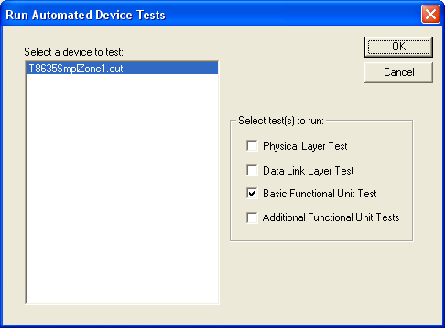
Automated tests are like script tests except that the Enviracom Bus Monitor generates the tests automatically, by knowing the messages that the device sends and receives. Automated tests should usually be performed with the device under test being the only Enviracom device in the system. Before performing automated tests, make sure the list of devices in the system is correct by selecting ‘Edit’, ‘Identify Devices to Test …’ from the menu at the top of the main window. Follow the directions per Figure 7. To perform automated tests, click on the ‘Test’ button on the tool bar near the top of the main window. A dialog box appears as shown in Figure 12.
Figure 12: Run Automated Device Tests

To the left will be a list box showing all of the devices in the system. In most cases, there should only be one device in the list, however the automated tests can be run with mulitiple devices. Select the device you wish to test. To the right are four levels of testing that you can select in any combination. After selecting the desired tests, click the ‘OK’ button to begin testing.

Physical Layer Test
The physical layer test is described in the Enviracom Physical Layer Specification. It checks the device’s recognition of 10 consecutive Node Identification 1 queries for all worst case combinations of AC voltage, number of devices on the bus, and common mode voltage. The test prompts the user to make manual changes to these parameters at appropriate times.

Data Link Layer Test
The data link layer test checks the device against the Enviracom Data Link Layer Specification. The test runs without user intervention.

Basic Functional Unit Test
The basic functional unit test checks each message the device sends and received against many of the rules in the Enviracom Functional Unit Specification. This test runs without user intervention.

Additional Functional Unit Test
The additional functional unit test makes more checks that the basic functional test doesn’t. This test takes approximately 95 minutes to complete. During the test, the user is prompted to remove and restore system power.

Script Tests
These tests are user written scripts that send messages to the device, which cause the device to experience as many operating states as possible. These tests are intended to show product quality and would be a normal step in any product development, but because the Enviracom Bus Monitor is listening to bus traffic during these tests, a side benefit is to show Enviracom conformance.

Functional Tests
These are tests that put the device through its paces to show that it is functional in all situations. These tests are created and executed by developers as a normal step in product development. By allowing the Enviracom Bus Monitor to listen to bus traffic during these tests, a side benefit is to show Enviracom conformance.

Serial Adapter Protocol
This section documents the serial protocol with the W8735A Enviracom Serial Adapter and the Fast Enviracom Serial Adatper.

19.2 Kbits/sec
1 start bit
8 data bits
1 stop bit
Full duplex
No DSR or DTR used
No Xon/Xoff used

From EnviraCOM Serial Adapter to PC
As the EnviraCOM serial adapter receives each bit on EnviraCOM, it sends that bit as a serial character to the EnviraCOM Bus Monitor. All bits are sent serially, including stuff bits and bus idle bits.
A recessive bit is sent as a ‘-‘ character (2D hex), and a dominant bit is sent as a ‘+’ character (2B hex), with the exception of the StartOfFrame bit in an EnviraCOM message. The StartOfFrame bit is sent as follows:
Fast Enviracom Serial Adapter: ‘^’ character (5E hex)
W8735A Serial Adapter: ‘+’ character (2B hex)
The StartOfFrame bit tells the EnviraCOM Bus Monitor whether standard EnviraCOM or Fast EnviraCOM is being used.

Since the serial adapter is constantly receiving bits on EnviraCOM even when the bus is idle, there will be a constant serial stream of characters from the serial adapter. With standard EnviraCOM, the serial stream will be 120 characters / sec. With Fast EnviraCOM, the serial stream will be approximately 1000 characters / sec.

Approximately 2 seconds after the serial adapter powers up and before any other serial characters are sent, the serial adapter also sends the following character string:
“[Reset]” (quote characters are not sent)
Any EnviraCOM bits prior to the [Reset] string are not sent serially (thrown away) by the serial adapter.

From PC to EnviraCOM Serial Adapter
All communication from the PC to the EnviraCOM Serial Adapter (either standard or fast) is for the sole purpose of telling the serial adapter what sequence of bits to send on EnviraCOM.

A serial message to the serial adapter has the following format:

<Y><sequence of dominant/recessive bits><CrLf> where:

<Y> = the ‘Y’ character (59 hex)
<sequence of dominant/recessive bits> = ‘+’ character(2B hex) is dominant, ‘-‘ character(2D hex) is recessive
<CrLf> = carriage return and line feed characters (0D hex, 0A hex)

The message is the same regardless of whether standard or fast EnviraCOM is being used. Each serial message can be up to 800 characters max, and can include multiple EnviraCOM messages. The sequence must include the bits for all Data Link Layer fields to send on EnviraCOM, including StartOfFrame, CRC, ACK, EndOfFrame, and stuff bits. Once the serial message is received, the serial adapter will attempt to send the sequence of dominant and recessive bits at the next occurance of the EnviraCOM bus being idle. If the serial adapter loses arbitration while sending the sequence, it will abort the attempt and retry at the next occurance of the EnviraCOM bus being idle. This will continue until the entire sequence is sent, a new sequence is received from the PC, or an empty sequence is received from the PC.

There is no feedback from the serial adapter to the PC that the sequence was successfully sent, other than the serial stream of EnviraCOM bits received by the serial adapter.

